Level 2 Creating an event driven computer program using C# (7540-008)

Author: Bogdan Pasterak 06/03/19

Task B

1.

I found an error in the program. Using the debugger, I convinced that it was not on my side. The discrepancy concerns one euro cent.

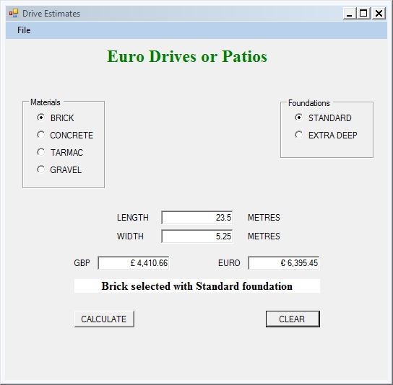

The Euro amount specified in the requirements was € 6,395.46.

With the help of the Debugger, I traced the calculation process.

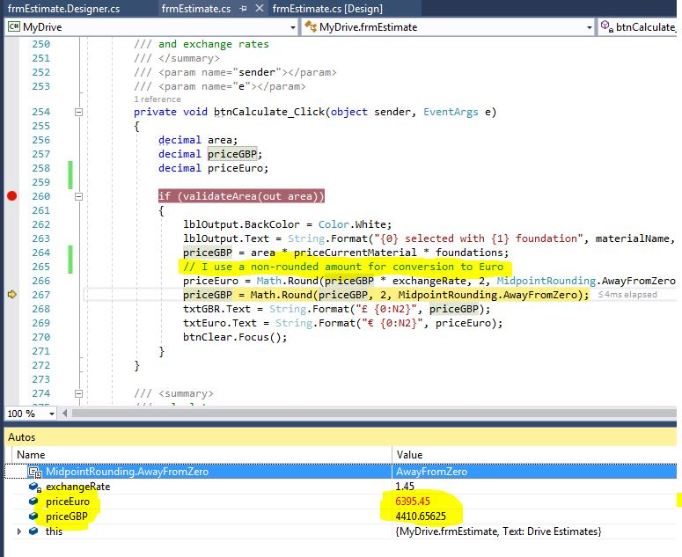

During debugging, I changed the value of priceGBP to a rounded value 4410.66.

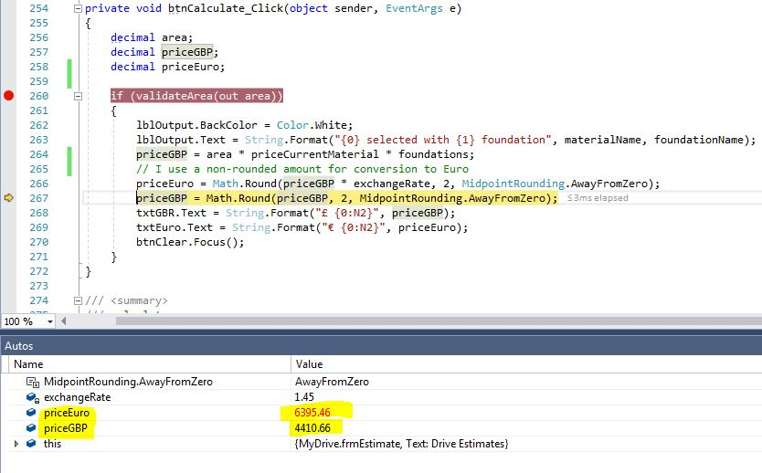

The result of the calculation turned out to be identical.

It turned out that in the case of calculations for conversion, the rounded amount of GBR was used. My conversion software used all the value.

## 2.

I use Excel to test my calculations.



|  |  |  |  |  |
| --- | --- | --- | --- | --- |
| **Start Data** | | | | |
| **Exchange** | **Brick** | **Concrete** | **Tarmac** | **Gravel** |
| 1.45 | 35.75 | 25.5 | 20 | 29.75 |
| 1.1 | 35.75 | 25.5 | 20 | 29.75 |

|  |  |  |  |
| --- | --- | --- | --- |
| **Entered Data** | | | |
| **Selected material** | **Selected foundations** | **Length** | **Width** |
| Brick | Standard | 23.5 | 5.25 |
| Tarmac | Extra Deep | 11.6 | 3.32 |

|  |  |  |  |  |
| --- | --- | --- | --- | --- |
| **Calculation** | | | **Results** | |
| **Area** | **Area * Price** | **\* Foundation** | **GBP** | **Euro** |
| 123.375 | 4410.65625 | 4410.65625 | 4410.66 | 6395.45 |
| 38.512 | 770.24 | 962.8 | 962.80 | 1059.08 |

The results of my program below

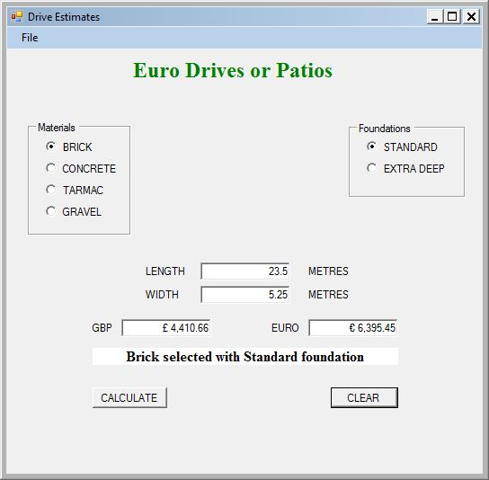

## 3.

I made calculations of the second set of data on the executable copies of the program.

